19th – 21st August 2022

LCSB Summer Gathering 2022 – ONLINE ATTENDEE FORM
Via Zoom, Lay Community of St Benedict
Come and join The Lay Community of St Benedict for our Summer Gathering at Worth Abbey, Paddockhurst Rd, Turners Hill, W. Sussex RH10 4SB,
from Friday 19th – Sunday 21st August 2022.
“Is there anyone here who yearns for life and desires to see good days?”
Prologue 15 (Ps 33[34]:13)

The theme of our Summer Gathering is ‘Creating Holy Space’. We will spend the weekend reflecting on how we build holy space, and find the sacred amidst the mundane, as Christians in our current world. There will be monastic input, speakers, workshops, a chance to book individual time with a monk, a games afternoon, Lectio Divina, a BBQ, entertainment (and your chance to get a little involved musically); and, of course, the AGM.
Please either complete this 2-page form, or the online Eventbrite form:
https://www.eventbrite.co.uk/e/lcsb-summer-gathering-19-21-august-2022-worth-abbey-registration-354617950837
Name(s):
Address:
Telephone: |  | Email:
If over 18, circle age range: | 18-25 26-35 36-45 46+ | Date of Birth if under 18:
Would you like a printed
copy of the Summer Gathering booklet?
Permission given for use of photos in publicity? (Adults: please sign to give permission. Parents need to sign for anyone under 18)
Any Access Needs? (e.g. large print materials/ picture timetable/ need help to access Zoom)
Have you been to an LCSB online event before?
Any other information we should know, to help you participate fully in our celebration?

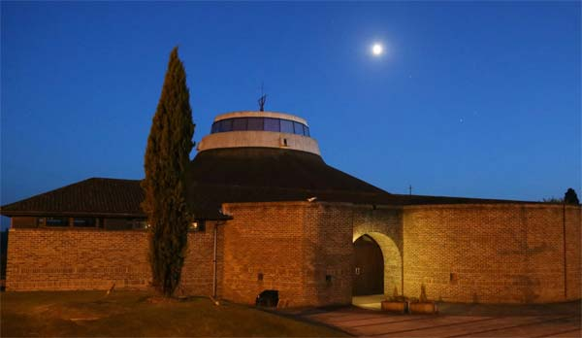
Living As Community
This event is only possible if we all play a part in making it happen.
In response to the call of Christ, I offer myself to Almighty God
By the help of the Holy Spirit, with the love of the Lay Community of St. Benedict,
to live Holy Communion, create Holy Space and offer Holy Service,
in the ways in which my circumstances allow
If you already have any of these ministries, and you feel you are called to serve in these areas at the Summer Gathering, please tick the appropriate boxes and we will contact you. Everyone attending will be allocated at least one role to assist in the running of the weekend.
Zoom hosting | Name:
Facilitating Zoom discussion groups | Name:
Are there any days/sessions you cannot do?

HOW TO BOOK YOUR PLACE:

To book either email your completed form to laybenedictines.bookings@gmail.com or post it to: LCSB Bookings Secretary, 12 Greville Court, Bookham, Leatherhead, Surrey KT23 4DS.
Or fill in an online form on Eventbrite: https://www.eventbrite.co.uk/e/lcsb-summer-gathering-19-21-august-2022-worth-abbey-registration-354617950837
We are not charging online attendees. However, if you would like to contribute financially, our suggested voluntary donation is £35. Please make your payment online using the following information: Sort Code: 40-52-40 Account Number: 00011133 with reference “SG2022” and your surname; or post a cheque payable to “The Lay Community of St Benedict” with your booking form.

BOOKING DEADLINE: FRIDAY 15TH JULY 2022

The LCSB reserves the right to decline an application for any event if the organisers believe that the applicant’s individual needs cannot be met on this occasion. Such decisions will be made after careful review of an identified need for support with the applicant’s help, and all reasonable efforts will be made to find volunteers to provide necessary support, or to make suitable accommodation arrangements.

The Lay Community of St. Benedict. Registered Charity No. 1100638. Incorporated in England and Wales as a company limited by guarantee No. 04838564. Registered office: 2 Egdean Walk, Sevenoaks, England, TN13 3UQ. The Community is registered as a data controller under the Data Protection Act 1998, Registration number Z8223334.

Data collected by LCSB will be held securely in accordance with the LCSB Data Protection Policy (https://www.lcsb.uk/policies)

